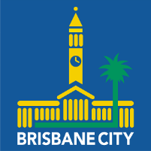
‘Local Heroes’ - Community Service Awards
2026 Nomination Form

Purpose

To recognise the extraordinary contribution of volunteers, our local heroes, who work tirelessly in our community.

Eligibility

The Awards are open to volunteers living in or active members of a community group based in Tennyson Ward and/or Moorooka Ward in the Brisbane City Council area. The Awards recognise the work of volunteers whose selfless efforts have helped to improve the lives of others and/or those who have helped to build community spirit, resilience and identity in our local area. Up to ten people will be recognised annually.

Nominations

Open - Monday 16 February 2026

Close - Friday 8 May 2026

Submit entries to - tennyson.ward@bcc.qld.gov.au and/or moorooka.ward@bcc.qld.gov.au

Recipients announced – Saturday 13 June 2026 at the Oxley Bowls Club, Englefield Rd, Oxley.

Nomination Form

You may add supporting material no longer than 2 or 3 pages, including any photos, to your nomination

NOMINEE’S DETAILS
First Name: |  |  |  |  |  | Last Name:
Address: |  |  |  |  |  |  |  |  | Suburb:
Phone: |  |  |  | Email:
Reason for nomination (250-500 words):
List of volunteer community work and/or membership and or positions:
NOMINATOR’S DETAILS
First Name: |  |  |  |  |  | Last Name:
Address: |  |  |  |  |  |  |  |  | Suburb:
Phone: |  |  |  | Email:

